MACH4METAL

metalworking machinery
Transito 21
6909 DA BABBERICH Netherlands
Tel. +31 (0)316-247123
Fax: +31 (0)316-247956
info@mach4metal.com
www.mach4metal.com

Bank No : 66.52.13.883
IBAN : NL33 INGB 0665 2138 83
BIC : INGBNL2A

Schröder CNC Folding machine
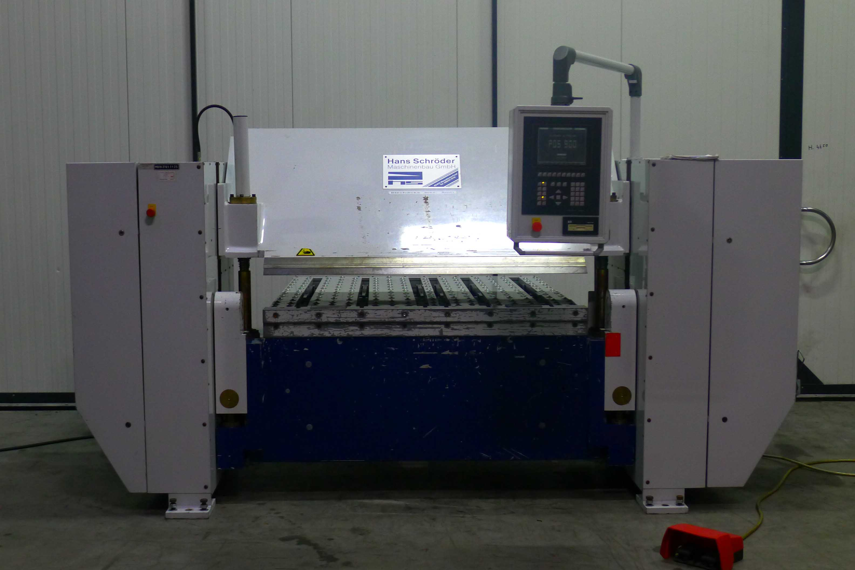
- Merk : Schröder Fasti Germany
- Type : MAK 4 x 8,0
- Mach.No : 230072
- Bouwjaar : 1998

- Folding length : 1.520
- Plate thickness : 8 mm

- Stroke upper beam : 350
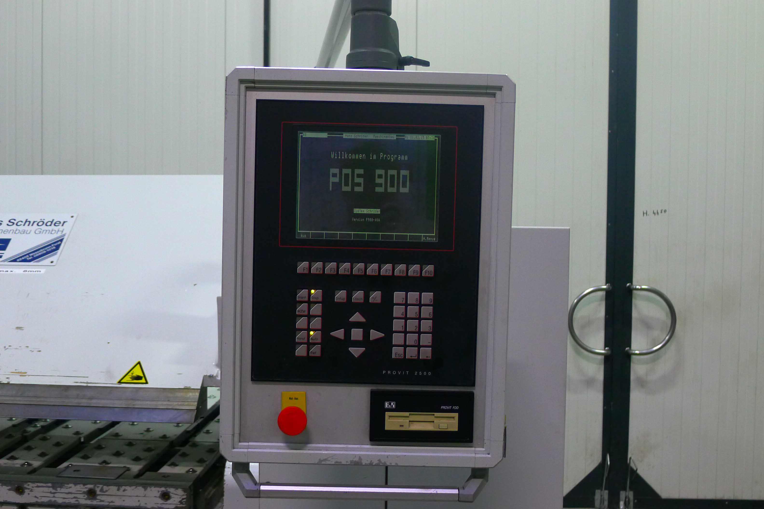
- Adj. Vertical bend beam : 80
- Power : 7.5 kW

- SCHRODER – POS 900 Positioning
Back gauge 2 fingers 1.000 mm
- Controlled Axis are;
- X = rear stop
- Y = bending beam
- Z = upper beam
- A = lowering of bending beam
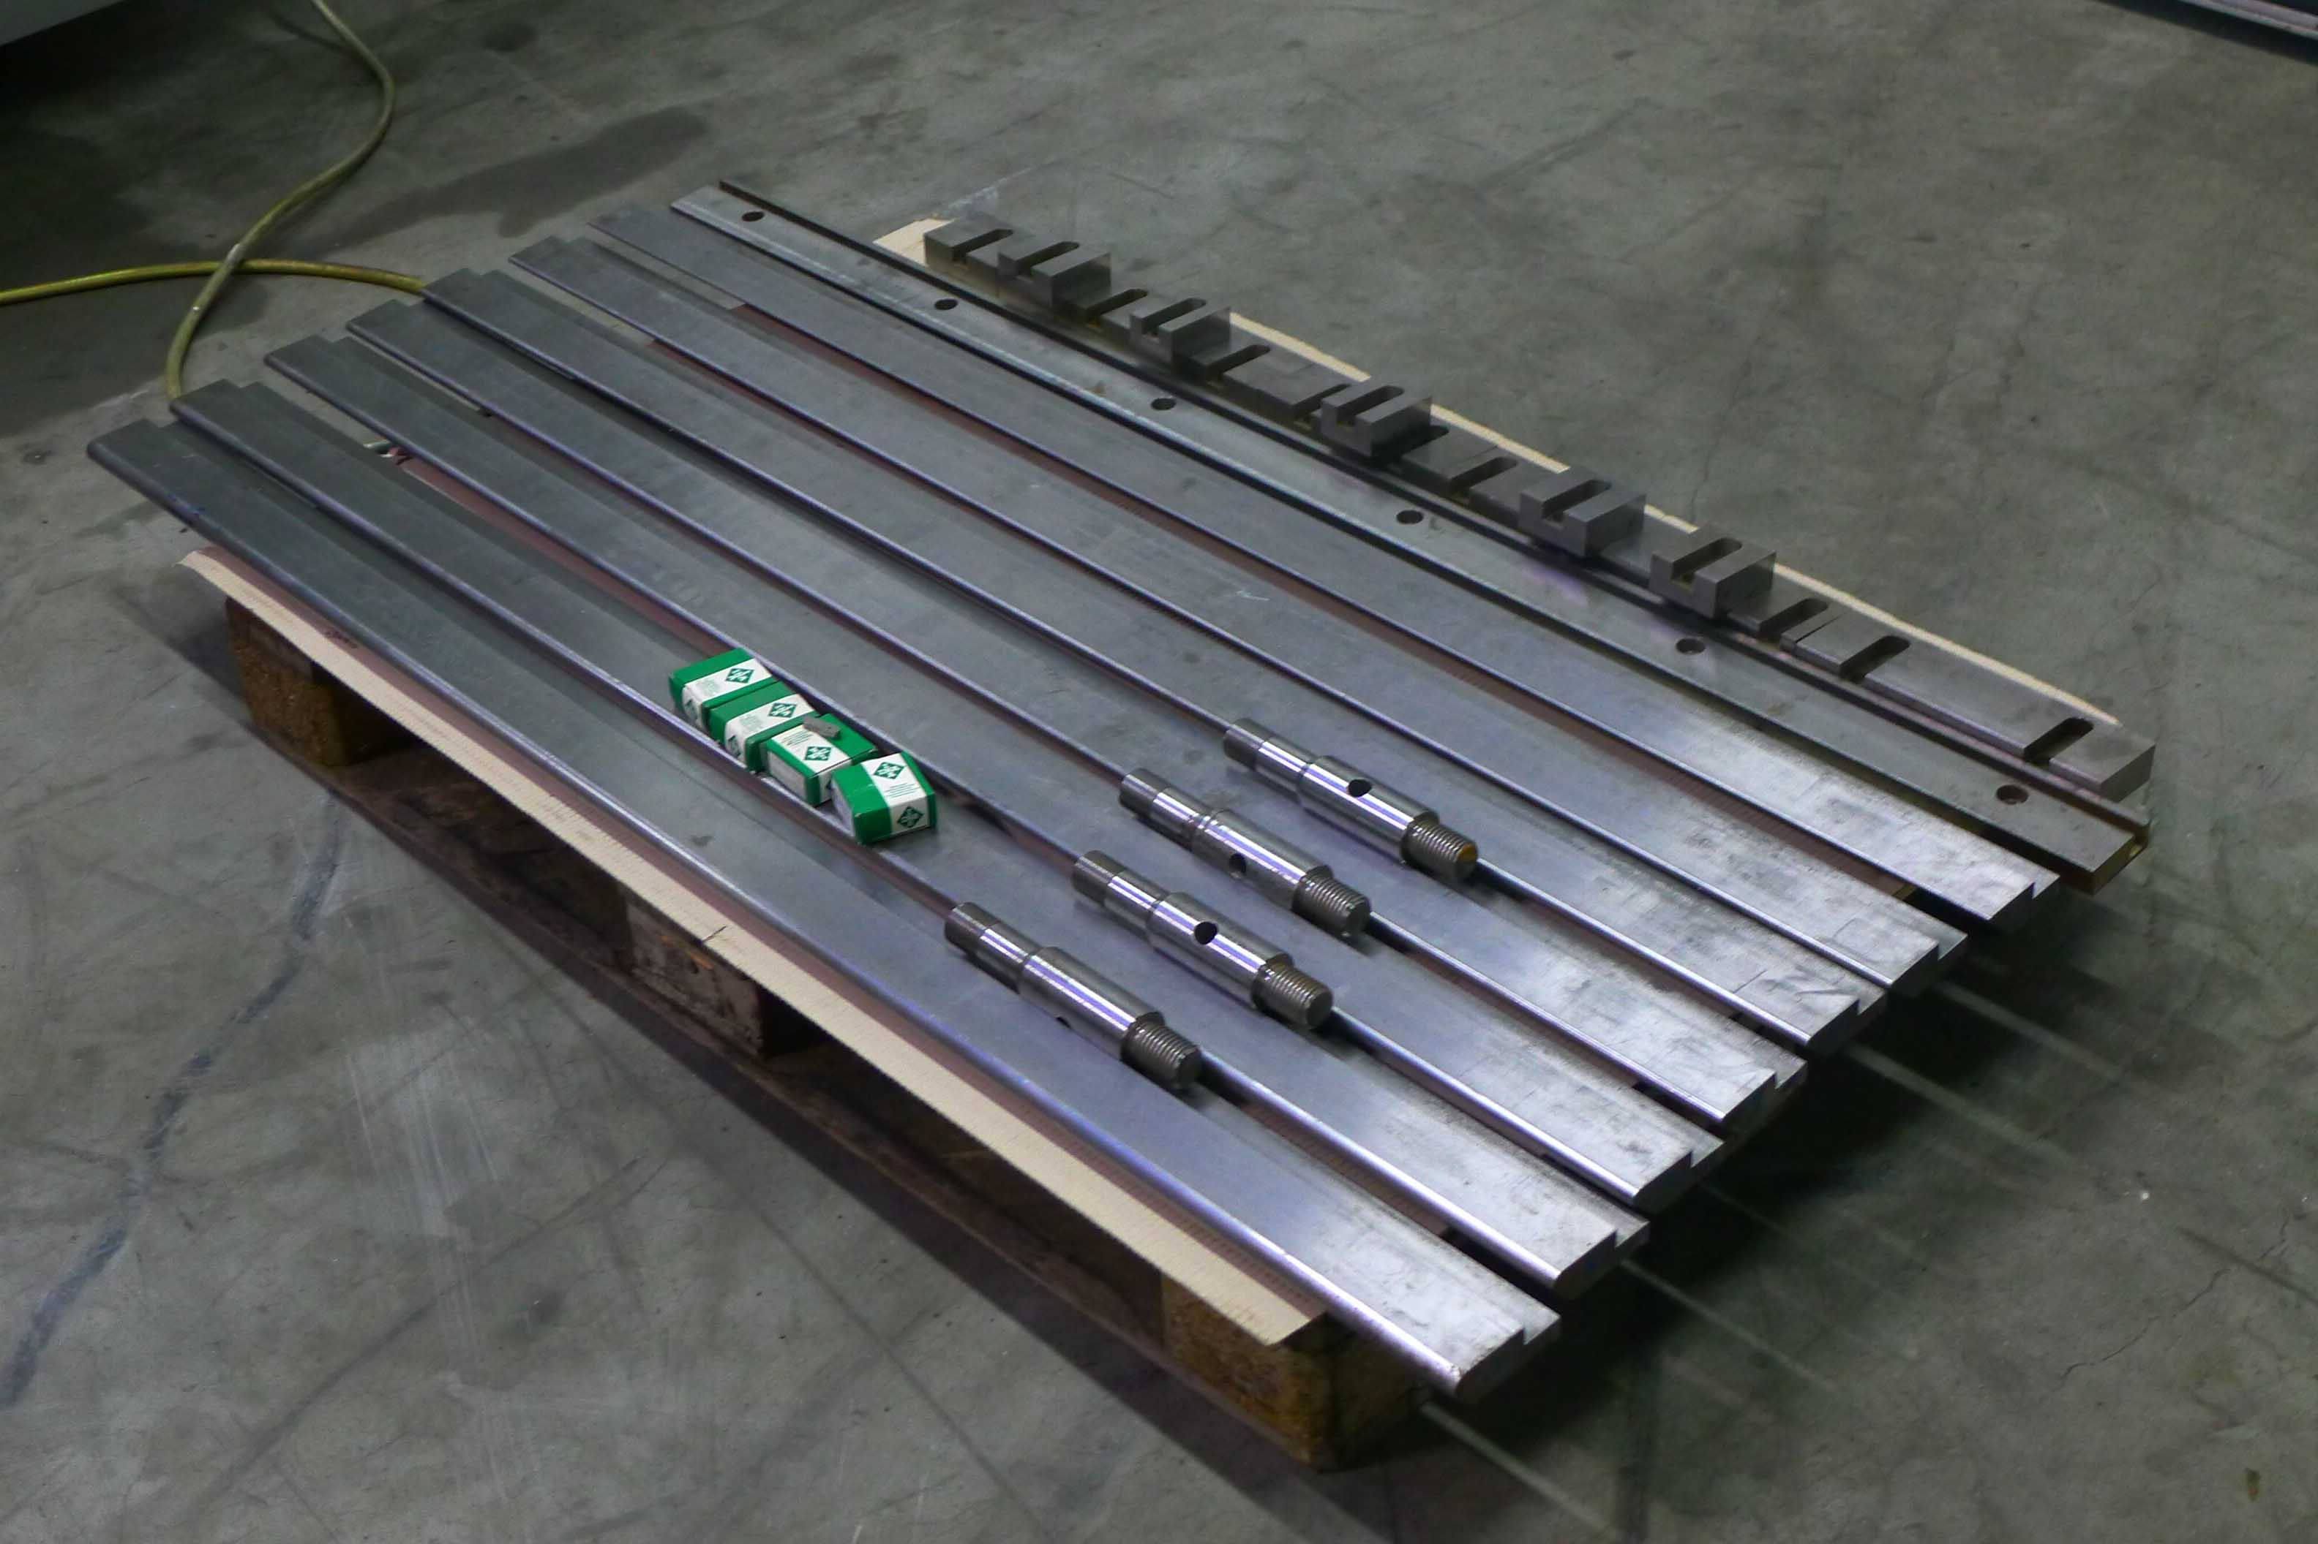
- B = lowering of lower beam

- Dimensions
- Length : 3.222
- Width : 2.510
- Height : 1.832
- Weight : 3.050

- Hydraulic upper tool clamping
- 8 x Sharp tool 45˚ to max 135˚ R 1.5/2/3/4/5/6/8/10
- New Euro 150.000

Please Note: The above information has been obtained to the best of our ability and belief from, and from the manufacturers where possible. It is given in good faith, but its accuracy can not be guaranteed. Accordingly, it will not form a representation or constitute contractual terms. We advise you to check any vital details!

